Bulgarian Diploma Thesis

TimeTree: A Lightweight Local Version Control System

Viktor Logodazhki, ID# 200190541

Student: , Date:
signature

Supervisor: , Date:
signature

Department of Computer Science, AUBG
Blagoevgrad, 2025
Declaration template for Senior Project and Diploma Thesis

Title: TimeTree: A Lightweight Local Version Control System

Author: Viktor Logodazhki

Abstract: Version control systems (VCS) like Git provide tools for managing code changes in collaborative development environments. However, many users find these systems complex, especially in terms of setup, configuration, and usage. This project, TimeTree, aims to address these challenges by implementing a custom, lightweight version control system. Built in Kotlin, TimeTree provides a simple command-line interface (CLI) for performing core VCS tasks such as initialization, file staging, commit creation, and branch management. At the heart of the system is a custom SHA-1-style hashing algorithm and a Myers LCS implementation for diffing and a rolling checksum algorithm for large files. The application’s features include essential VCS functionalities like commit, status, log, diff, and branching, with an intuitive CLI for user interaction. It also ensures data integrity and consistency through its use of object storage and atomic operations. TimeTree is designed to be extensible, with future improvements including interactive log graphs, commit statistics, and supporting more hashing algorithms. This project not only provides a simple, reliable local VCS but also demonstrates the potential for building lightweight, custom solutions tailored to user needs. With additional features and polish, TimeTree can serve as both a functional tool and a research prototype for future version control systems.

Declaration of authorship:

“The Senior Project/Bulgarian Diploma Thesis presented here is the work of the author solely, without any external help, under the supervision of ….. All sources, used in development, are cited in the text and in the Reference section.”

Author:

Table of Contents
1. Introduction 4
1.1 Motivation 4
1.2 Project Overview 5
2. Specification of the Software Requirements and their Analysis 6
2.1. Functional Requirements 6
2.2 Non-functional Requirements 7
2.3 Requirements Analysis 8
2.3.1 Analysis of Functional Requirements 8
2.3.2 Analysis of Non-Functional Requirements 14
3. Design of the Software Solution 15
3.1 Main Algorithms 15
3.1.1 Content Addressing with SHA-1 Hashing 15
3.1.2 Myers Line-Based Diff Algorithm 17
3.1.3 Rolling Checksum for Binary Deltas 18
3.2 Algorithm Complexity 19
3.3 Software Architecture 21
7. References 22

1. Introduction

1.1 Motivation

As a front-end developer, I use Git every day, but for years it felt like a powerful black box: I could memorize the workflows: add, commit, push - yet the why behind objects, refs, and history I could never understood them. My primary goal in this project is to open that box by building a small, working system that mirrors Git’s core mechanics. By re-implementing the pieces myself - content-addressed objects for integrity, a staging area, deterministic trees for reproducible snapshots, commits with parents, and symbolic references (like HEAD) to identify the current branch - I’m forcing myself to internalize not just how commands behave but what data structures make them safe and predictable.[1] [2].

Finally, this project is a platform for experimentation. Mature VCSes must balance decades of history, ecosystem constraints, and backward compatibility; they are difficult places to explore and create new features. A compact, layered, Kotlin implementation makes it feasible to prototype ideas quickly, measure their trade-offs, and keep only what improves clarity, correctness, or robustness. For example, such experiments are the deterministic object storage I am creating to achieve the same repository state across different platforms, and the adaptive delta compression based on rolling checksums to optimize file synchronization. In short, TimeTree is both a learning and a practical tool: it helps me understand how Git works by building a working version of its core, while also paving the way for research-quality experiments in determinism, storage, and differencing - the latter grounded in well-studied techniques such as Myers’s O(ND) algorithm [3].

1.2 Project Overview

TimeTree is a lightweight, local version control system implemented in Kotlin with a small, command-line interface. The system focuses on the essential snapshot pipeline: init creates the repository skeleton under .timetree/, add streams file contents into a content-addressed object store and records paths in a staging index, and commit converts the staged state into a deterministic directory tree and a commit that updates the current branch. A helper command compares Git-style and TimeTree-style object IDs to illustrate domain separation. The goal is a tool that is easy to reason about end-to-end while remaining faithful to the core ideas behind mature VCSes like the most used one - Git.

At the heart of TimeTree is a compact object model. Files are stored as blobs - raw bytes addressed by a SHA-1 - based identifier computed over a namespaced header and the content. A tree serializes a directory snapshot as stable, human-readable lines that list modes, names, and object IDs; entries are sorted so identical input always yields the same tree ID. A commit records the root tree, optional parent commit, author/committer information, and the message, forming a simple history DAG (Directed Acyclic Graph). Objects are immutable and persist in .timetree/objects/, addressed by their IDs, which makes the repository auditable and easy to inspect with standard tools.

Architecturally, TimeTree is organized in clear layers. The CLI layer handles argument parsing and user feedback. The core services provide repository layout, object storage, index management, reference updates and all the core functionality behind the CLI commands. Above them sit small writers/builders that translate staged entries into tree bytes and commit payloads. This separation keeps the codebase approachable, enables focused unit tests, and makes it straightforward to extend the system with additional commands without any concerns of breaking other code. Essentially following the separation of concerns principle. [4]

Testing accompanies the implementation throughout. The hashing module is verified against known vectors; the init and add commands are tested for correct repository structure and path normalization; the commit command is validated end-to-end by inspecting on-disk blobs, trees, commits, and updated refs. These are just some of the tests. Every command that is in the project has dedicated tests to ensure they are all working correctly.

TimeTree is deliberately built to be scalable and easy to extend. The command surface follows a clean command pattern so adding a new feature - status, log, diff, branch, checkout, or a porcelain wrapper - means wiring a new subcommand that composes existing services rather than modifying core logic. The layered design keeps dependencies one-way and narrow, which makes changes local and lowers regression risk. Finally, comprehensive tests provide a safety net, so new commands can be added quickly without any problem. In short, TimeTree’s architecture favors incremental growth: small, composable commands over a stable, deterministic core, enabling the project to evolve in capability without increasing complexity.

2. Specification of the Software Requirements and their Analysis

2.1. Functional Requirements

1. The application should initialize a new repository, creating the .timetree/ directory with objects/, refs/heads/, the HEAD file pointing to refs/heads/master.
2. The application should stage files with the add command by streaming their contents, storing a blob object in .timetree/objects/, and recording a repo-relative POSIX path and object ID line in .timetree/index. Files inside .timetree/ must be skipped.
3. The application computed deterministic object IDs using a SHA-1 - style hasher over a namespaced header and content, ensuring stable IDs and domain separation from Git.
4. The application created commit objects containing tree, optional parent(s), author/committer, timestamps, and message; the first commit had no parent, subsequent commits formed a history DAG.
5. The application advanced branch references atomically, writing the new commit ID to refs/heads/<branch> while keeping HEAD as a symbolic ref; the CLI printed Switched to branch [branch].
6. The application provided status, comparing working tree vs. index vs. HEAD and listing staged/unstaged/untracked changes.
7. The application provided log, walking parents from the current ref and displaying abbreviated IDs, timestamps, authors, and messages in reverse chronological order. Includes option the option --all for showing all commits in the repository.
8. The application provided diff, showing line-level changes between blobs/commits/trees/branches based on a Myers O(ND) - style algorithm, with clear +/- hunks.
9. The application included hash-object command to display/compare Git-style vs. TimeTree IDs.

2.2 Non-functional Requirements

1. Crash-safe repository state via atomic write-then-move for objects, index, and refs, object contents verified with cryptographic hashes.
2. Repository state (blobs, trees, commits, refs, index) stored as plain files, human-readable where possible, enabling manual inspection.
3. Works on macOS, Linux, and Windows. Index stores repo-relative POSIX paths so behavior is consistent across platforms.
4. Concise CLI with --help or -h for each command, clear single-line confirmations/errors, and correct exit codes. Each command has a maximum of 10 sentences concise description, and max 5 flags.
5. Layered architecture and Command pattern allow adding new commands (e.g. merge, reset, stash) by composing existing services without modifying core logic.
6. Performance should feel instantaneous; every command should not have noticeable delays. Committing up to 100 small/medium files finishes in under a second; text diff of less than or equal of 10 MB completes around a second; updating/checkout of around 1000 tracked files completes around two seconds. Overall, near instantaneous performance.
7. Scalability should not be a problem. The project is designed to grow over time, handling thousands of files and objects; committing over 10000 should not be a problem, over 100000 objects should not be a problem, and repositories up to 5 GB should not be a problem. All of this is possible thanks to the rsync algorithm.
8. The system defends against partial writes, truncated objects, and path confusion. Writes are fsynced and atomically renamed; object headers, sizes, and types are strictly validated; refs are updated atomically.

2.3 Requirements Analysis

2.3.1 Analysis of Functional Requirements

The core of the application lies with the selected commands that are implemented, and the logic behind them. For that reason, the functional requirements follow logical order. They were selected because they are at the core of how a version control system (VCS) should behave. The algorithms that are running the project also are at the core of what a VCS is. Now I will be explaining what each of the requirements is about.

1. The init command creates the repository’s deterministic, inspectable scaffold. When run in a writable working directory, it builds .timetree/ with objects/ for content-addressed blobs/trees/commits, refs/heads/ for branch pointers, and a HEAD file that is a symbolic ref to refs/heads/master. This keeps the user on an explicit branch from the start and aligns the later workflow.

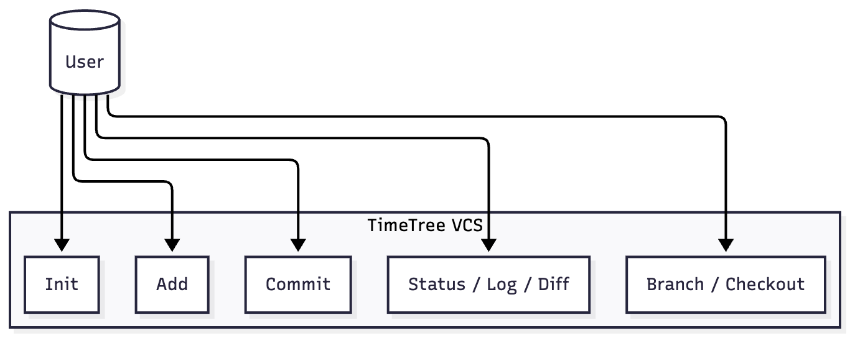
Figure 1 - Use Case Diagram of the Core TimeTree Commands

The operation is idempotent and crash-safe. If .timetree/ already exists, the command verifies/repairs the expected structure instead of failing, ensuring objects/, refs/heads/, and a well-formed HEAD. Files are written via atomic “write-then-move” to prevent torn writes. This satisfies reliability and transparency goals by leaving state consistent even on failure. Edge cases are handled with clear outcomes: non-writable directories or a non-directory .timetree yield a descriptive error and non-zero exit; partially initialized repos are repaired by creating only missing pieces.

2. The add command stages one or more paths by streaming file bytes through the SHA-1 - style hasher (with TimeTree’s namespaced header) and writing a blob to .timetree/objects/. For each successfully hashed file, it records a single line in the index as <40-hex-id> <relative-path>. The command prints a concise confirmation per file so the user sees exactly what will be committed. Before processing, add validates inputs to protect repository integrity and user intent. Any path outside the repo root and under ./timetree is skipped. For duplicate paths, the latest blob ID replaces the previous entry in the index, which keeps the staging area a simple, last-writer-wins map. The index file itself is persisted atomically (write-then-move) so partial writes can’t corrupt staged state.

3. TimeTree computes object identifiers by hashing a namespaced header concatenated with the exact object bytes, ensuring determinism and domain separation from Git. For a blob, the header is "timetree:v1\0blob <size>\0"; for trees and commits, analogous headers are used. The stream of bytes header and content is fed into my custom SHA-1 hasher, so identical inputs always yield the same 40-hex ObjectId, while the same content hashed with Git’s header ("blob <size>\0") yields a different ID. This prevents cross-tool collisions and makes IDs stable.

4. Given the root tree ID and the current tip (if any), the commit writer assembles a deterministic payload containing tree <treeId>, optional parent <commitId> (omitted on the first commit), author and committer identities with timestamps, and the message, then hashes header and payload using the TimeTree commit header to produce the immutable commit object, which is stored under .timetree/objects/. Empty messages are allowed with the flag --allow-empty.

5. After writing the commit object, the system atomically advances the current branch by writing the new commit ID into refs/heads/<branch> while keeping HEAD as a symbolic reference (ref: refs/heads/<branch>). The update uses a write-to-temp-then-rename strategy to prevent torn writes, so a crash never leaves a half-written ref. On fresh repositories, <branch> is the default from HEAD (master).

6. The status command compares three views of the project - the working tree, the index, and the HEAD tree - to classify paths as staged (index different than HEAD), unstaged (working hash different than index), or untracked (present in working tree, absent from index).

7. The log command shows the commit history starting from the tip of the current branch, repeatedly reading each commit object, and printing its information. Each entry displays the abbreviated commit ID, timestamp, author, and the first line of the message, in reverse chronological order. Because commits are immutable and linked by parent IDs, traversal is simple and deterministic.

8. The diff command shows line-level changes between two versions - either two blobs directly or two commits/trees by matching files with the same path. It uses a Myers O(ND) - style algorithm to compute a near-minimal edit script and renders a unified diff with - (deletions), + (additions), and a few context lines for readability.

9. The hash-object command demonstrates domain separation and determinism by computing two IDs for the same file: a Git-style ID and a TimeTree-style ID. Because the headers differ, the resulting 40-hex digests are intentionally not equal even when the content is identical, proving that TimeTree objects cannot collide with Git’s namespace.
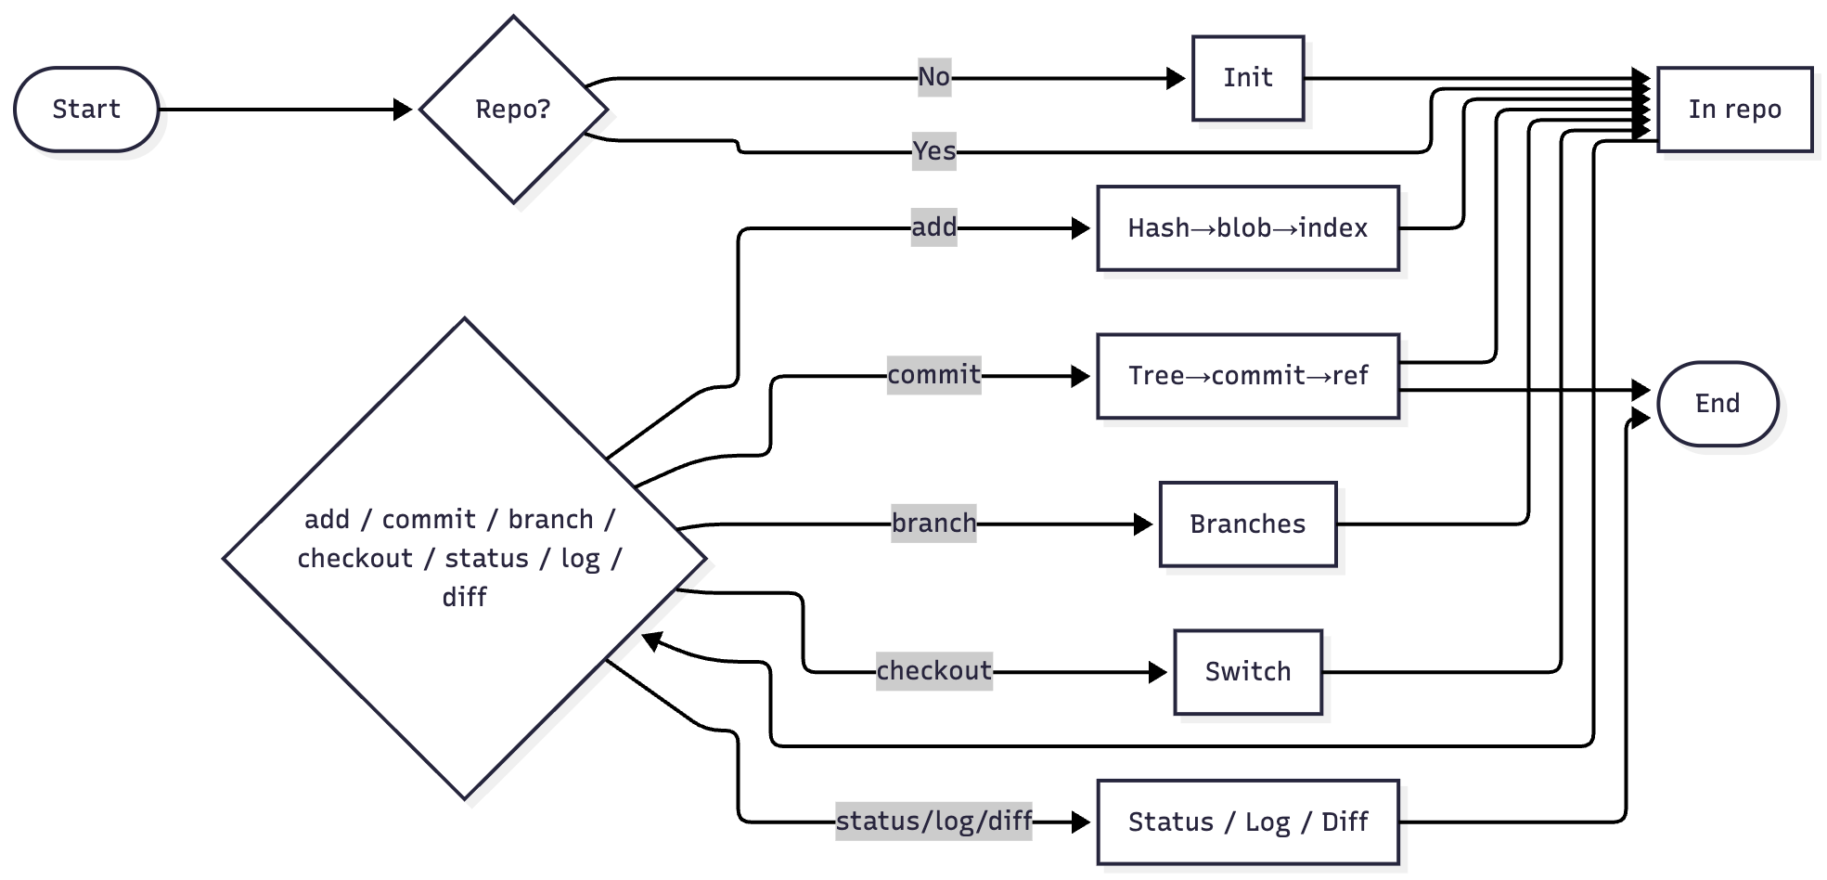
Figure 2 - Activity Diagram of the TimeTree Command Workflow

Finally, let us analyze some specific use case narratives for the application. This is important because the project is user-focused and designed with the end user in mind throughout the whole implementation process.

i. Name: Initialize Repository
- Actor: User
- Entry Condition: The user is in a writable working directory without a valid .timetree/.
- Flow: The user runs timetree init. The system creates .timetree/objects, .timetree/refs/heads, and writes HEAD -> refs/heads/master.
- Exit Condition: A valid repository skeleton exists and the CLI confirms initialization.
- Exceptions: If .timetree exists but is broken, the system repairs missing pieces. If the directory is not writable or .timetree is a file, the command fails with an error.

ii. Name: Stage File(s)
- Actor: User
- Entry Condition: A TimeTree repo exists and at least one file is present in the working directory.
- Flow: The user runs timetree add <filename> or “.”. For each file, the system validates location, streams the file to the object store, and records <id> < relative-path> in the index file.
- Exit Condition: Selected files are staged and listed in .timetree/index
- Exceptions: Files outside the repo or under .timetree/ are skipped with a message.

iii. Name: Commit Staged Changes
- Actor: User
- Entry Condition: The repository has at least one staged file in the index.
- Flow: The user runs timetree commit -m "<message>". The system builds a deterministic tree from the index, creates a commit, writes it to the object store, and atomically updates refs/heads/<branch>.
- Exit Condition: A new commit exists, and the branch tip points to it.
- Exceptions: If nothing is staged (nothing to commit), the system prints “Nothing to stage - all files are already up to date.”.

iv. Name: View Status
- Action: User
- Entry Condition: A repository exists, and changes may have been made.
- Flow: The user runs timetree status. The system compares working tree, index, HEAD tree and lists staged, unstaged, and untracked files.
- Exit Condition: The user sees a summary of the current state.
- Exceptions: None beyond normal I/O errors, unreadable files are reported and skipped from classification.

v. Name: View Commit Log
- Actor: User
- Entry Condition: The repository has at least one commit.
- Flow: The user runs timetree log. The system shows the current branch and prints entries with abbreviated ID, author, timestamp, and commit message.
- Exit Condition: A reverse-chronological list of commits is displayed.
- Exceptions: If there are no commits yet, the command reports an empty history.

vi. Name: Show Diff Between Versions
- Actor: User
- Entry Condition: Two versions of a file exist
- Flow: The user runs timetree diff. The system matches files by path, computes line-level differences with the Myers diff algorithm and renders unified -/+ hunks.
- Exit Condition: A readable textual diff is shown for changed files.
- Exceptions: No staged changes meaning nothing to commit, I/O error.

2.3.2 Analysis of Non-Functional Requirements

TimeTree maintains a crash-safe repository state by using atomic write-then-move strategy for every update - objects, the index, and refs. Bytes are written to a temp file in the same directory, flushed, and only then renamed into place, so the repo can’t be left half-written after a failure. The objects are content-addressed with a cryptographic hash, so corruption is detectable. All repository items are plain files and intentionally human-inspectable. Blobs store raw bytes, trees and commits use compact line-based encodings, refs are single-line hex files, and HEAD is a readable symbolic reference - this makes debugging and auditing straightforward. The system is cross-platform: it runs on macOS, Linux, and Windows, and it normalizes every staged path to a repo-relative POSIX form. That guarantees identical inputs produce identical IDs across operating systems. The CLI is concise and friendly. Each command supports -h/--help, with all commands returning a result message - either a success one or a failure one.

Finally, the project is extensible by design. A layered architecture separates the CLI, core services, and builders/writers. Each subcommand is a small Command object that composes these services, so new features like merge, reset, or stash can be added without modifying low-level modules. Dependencies run one way (CLI to services to storage), keeping changes local and regression risk low. In terms of performance, everyday tasks are designed to feel instantaneous. Commits, diffs, and checkouts don’t stall the system and there is no noticeable slowdown. Every operation is performed in well under one or maximum of two seconds. For scalability, the project is optimized and there should be no problem with repositories under 5 GB. This size is perfect for the scope of the project. The rsync algorithm helps immensely with the optimization of storage. Security is not only limited to the hashing of the files, but every operation in the project is also strictly validated before proceeding. This is what the functional and non-functional requirements of the project are.
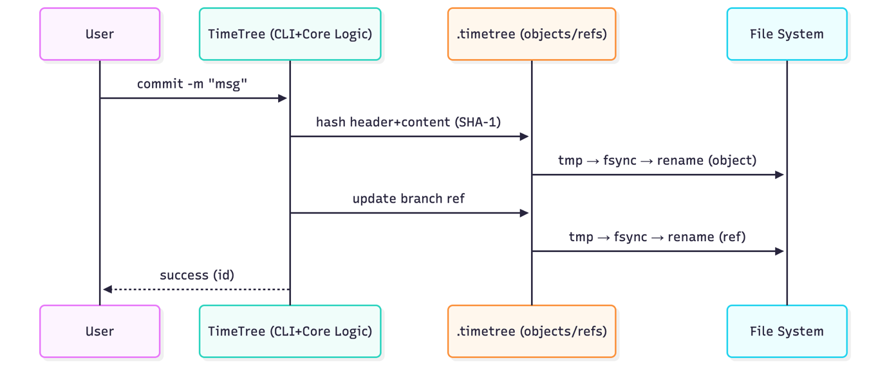
Figure 3 - System Workflow during a Commit Operation

3. Design of the Software Solution

3.1 Main Algorithms

The application has been developed using three algorithms. These three have been selected to fulfill all the needs of one fully working version control system. Those three are a custom SHA-1 - style hash for content addressing, the Myers Longest Common Subsequence algorithm for line-by-line diffs, and a rsync-inspired rolling-checksum algorithm for binary delta generation and application.

3.1.1 Content Addressing with SHA-1 Hashing

TimeTree names every blob, tree, and commit by hashing a canonical header plus the exact bytes - timetree:v1\0<kind> <length>\0 || content - using a streaming SHA-1 - style compressor. The 160-bit digest becomes the filename under .timetree/objects/, giving an immutable, content-addressed store where identical bytes always map to the same ID and any bit flip yields a different one. Here, the explicit namespace (timetree:v1) provides domain separation from Git [5]. This is basically what my custom SHA-1 does, but why have I chosen it?

There are a couple of reasons. Well, a NIST-standardized SHA family gives a well-studied primitive with a clean, verifiable storage model [5]. Another reason is that it mirrors Git’s historical object model which makes the mechanics easy to learn and validate. It’s small enough to implement transparently as a streaming compressor, so large files don’t need buffering, and the code stays relatively simple. The 160-bit IDs are ergonomic with abundant test vectors. In my local, single-user threat model, known SHA-1 collisions aren’t a blocker [6]. The timetree:v1 namespace keeps IDs separate from Git and preserves a clean upgrade path to SHA-256/BLAKE3 later. A reason for not choosing SHA-256, which Git will use in its new upcoming 3.0 version, is that it strengthens collision resistance but doesn’t change the mechanics I’m implementing and increases digest size/cost - so I treat it as a drop-in upgrade the header format already anticipates [7] . BLAKE3 follows the same reason as the SHA-256. While it may be significantly better, it adds complexity I don’t need for the current scope of the project. However, as mentioned aforehand, the migration to better hashing algorithms is open and can be done.

Let’s compare to other know algorithms - MD5, SHA-512 and CRC32. The the first one, MD5, is cryptographically broken. Chosen-prefix collisions have been demonstrated, meaning an attacker can create two different contents with the same MD5 resulting in different contents with the same hash [8], [9]. Continuing with SHA-512, it offers collision/preimage margins far beyond the project’s single-user model and adds digest size/CPU cost without any practical benefit here. NIST recommends to match the hash strength to the application needs [10]. Finally, the CRC32 is not a cryptographic hash. Its linear and easy to collide, its only suited for random-error detection [11]. Given all these trade-offs, SHA-1 with domain-separated headers keeps the design and implementation simple with a clean path for upgrades.

3.1.2 Myers Line-Based Diff Algorithm

TimeTree computes textual differences using Myers’s O(ND) algorithm, a dynamic programming approach for finding the shortest edit script (SES) between two sequences. It works by having two files represented as ordered list of lines that the algorithm uses to identify the minimal sequence of insertions and deletions that transforms one list into the other. In practice, it creates a search space of diagonals – each representing a fixed offset between positions in two files. Then it advances along the furthest-reaching paths in that space until the target end point is reached. After that the resulting trace is backtracked to produce a precise edit script of “keep”, “insert”, and “delete” operations. This algorithm is the same one that Git uses for its diff command implementation still standing as the default choice, while having the option to choose for other diffing algorithms such as patience [12]. Unix diff implementations also choose it for its balance between theoretical optimality and real-world performance [3].

There are several reasons as to why I chose the Myers algorithm for my diff implementation. First, it guarantees a minimal edit script in O(ND) time, where N is the combined number of lines and D is the minimal number of edits. This makes it efficient even for large text files with small differences. Second, it creates clean, human-readable diffs without the noise that simpler methods often generate. Third, it aligns perfectly well with TimeTree’s layered architecture. The diff engine is in the core layer, doesn’t care about files, it sees only two lists of lines, and is called by the CLI command layer, the diff command.

Alternative algorithms we considered. The dynamic programming matrix that is used in the traditional LCS algorithm also guarantees the same minimal result but consumes O(N²) memory, which is not good for files beyond a few thousand lines [13]. The Patience diff algorithm, the other option that git allows, offers the same but sacrifices optimality and determinism. It relies on experimentations that can skip valid matches under certain patterns [12]. Myer’s method, on the other hand, returns exact results with modest memory use (O(N+M)) and deterministic output. Those properties are crucial in my project. Overall, Myers’s diff was chosen because it is proven, optimal, and predictable. It fulfils all the needs of the project and can allow for further improvements such as the conflicts visualization.

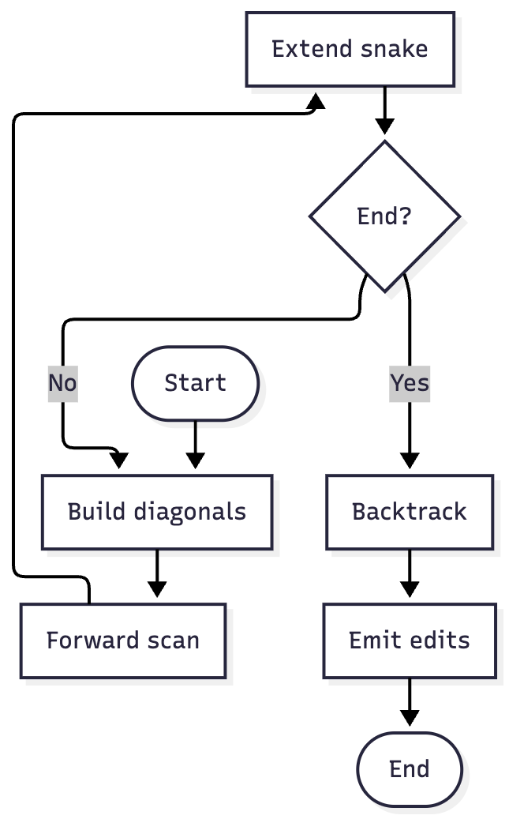
Figure 4 - Simplified workflow of the Myers Diff Algorithm

3.1.3 Rolling Checksum for Binary Deltas

TimeTree implements a rsync-style rolling-checksum algorithm to efficiently compute binary deltas between file versions. The goal of its implementation in the project is to avoid saving entire files when only small portions of the file have changed. A simple explanation of how it works is the following. The algorithm divides a basis file into fixed-size blocks and computes for each block both a weak rolling checksum and a strong hash - my own implementation of the SHA-1. After that during delta generation, the target file is scanned with a sliding window of the same block size. The rolling checksum then enables quick detection of matching blocks without rereading or rehashing the entire basis. When a match is found, the hash confirms it and unmatched regions become insert operations. The result sequence of “copy” and “insert” called delta reconstruct the target file from the basis. This entire approach is directly inspired by the original rsync algorithm by Tridgell and Mackerras [14]

Again, there are several reasons as to why I have chosen this algorithm. First, the rolling-checksum method scales well. It runs in linear time with respect to file size (O(n)) and uses a small amount of memory. Second, the algorithm is easy to implement and reason about. Its correctness can be proven from simple arithmetic transformations of the rolling checksum. Finally, it supports incremental synchronization and the possibility of future improvements and extensions.

Like the previous two algorithms, alternative options here were considered as well. One option is the block-wise cryptographic hashing. It requires recomputing all block digests after every byte shift. This makes it significantly slower for large files with small edits [15]. Binary differencing via bsdiff/vcdiff is also another option but it produces smaller deltas at a much higher computational cost and implementation complexity [16]. The rsync inspired approach is the most useful for TimeTree. It is fast, incremental, and deterministic.

3.2 Algorithm Complexity

All those algorithms implemented in Timetree were selected not only for their correctness and determinism but also for their efficiency. Each one of them - hashing, text differencing, and binary delta computation is designed to run in linear or near-linear time relative to the size of the processed data. This ensures the scalability to big repositories while keeping the implementation simple and not highly complex.

The custom SHA-1 hashing algorithm computes and digest in O(n) time, where n is the size of the input file. Here, each byte is processed once through 64-byte block updates, on which are performed a fixed number of arithmetic and bitwise operations. Since the algorithm woks as a streaming compressor, it does not buffer the entire file in memory. From this, the memory footprint it has remains constant O(1), determined only by the 160-bit initial state and a 512-bit message block. All of this allows TimeTree to hash large files efficiently and is limited only by the disk I/O bandwidth.

The second algorithm, Myers O(ND), computes the shortest edit script between two sequences in O(ND) time and O(N + D²) space, where N is the total number of lines and D the minimal number of differences [3]. Even better is when we have changes that are small compared to the file size, we get near linear performance. The implementation I have tracks the furthest-reaching position on each diagonal using two compact integer arrays that swap each iteration and record minimal backtrack metadata per step. This means that memory usage grows only with the number of lines. For ordinary files of a few thousand lines, the algorithm completes in milliseconds.

The third algorithm, the rsync-inspired rolling-checksum, runs in O(n) time and O(b) space, where n is the length of the target file and b is the block size. Each sliding-window update needs only a few arithmetic operations to roll the checksum forward which enables efficient scanning without recomputing full hashes for every shift. The delta application is also linear, as the operations it performs, “copy” or “insert”, are done one by one. Because it does only a small, fixed amount of work per byte, this works well for large files and incremental updates.

In contrast, the other alternatives for the algorithms have quadratic or higher costs in the worst-case scenario. An example of this is the cryptographic block hashing or suffix-array-based binary differencing (bsdiff) [16] Those algorithms can achieve slightly smaller deltas or better guarantees but are not suitable for TimeTree’s scope. Overall, the chosen algorithms, SHA-1 hashing, Myers line-based diff, and rolling-checksum delta provide great balance between speed, determinism, and simplicity while maintaining linear or near-linear runtime and constant memory usage.

3.3 Software Architecture

The application has been developed following a layered architectural pattern ensuring the separation of responsibilities, testability, and deterministic behavior.

7. References
[1] S. Perez De Rosso and D. Jackson, “What’s wrong with git? a conceptual design analysis,” presented at the Proceedings of the 2013 ACM International Symposium on New Ideas, New Paradigms, and Reflections on Programming & Software, New York, NY, USA: Association for Computing Machinery, 2013, pp. 37–52. doi: 10.1145/2509578.2509584.
[2] M. D. Beckman, M. Çetinkaya-Rundel, N. J. Horton, C. W. Rundel, A. J. Sullivan, and M. Tackett, “Implementing Version Control with Git and GitHub as a Learning Objective in Statistics and Data Science Courses,” J. Stat. Data Sci. Educ., vol. 29, no. 1, pp. S132–S144, Jan. 2021, doi: 10.1080/10691898.2020.1848485.
[3] E. W. Myers, “An O(ND) difference algorithm and its variations,” Algorithmica, vol. 1, no. 1, pp. 251–266, Nov. 1986, doi: 10.1007/BF01840446.
[4] “IEEE/ISO/IEC International Standard for Software, systems and enterprise--Architecture description,” ISOIECIEEE 420102022E, pp. 1–74, Nov. 2022, doi: 10.1109/IEEESTD.2022.9938446.
[5] N. I. of S. and Technology, “Secure Hash Standard (SHS),” U.S. Department of Commerce, Federal Information Processing Standard (FIPS) 180-4, Aug. 2015. doi: 10.6028/NIST.FIPS.180-4.
[6] M. Stevens, E. Bursztein, P. Karpman, A. Albertini, and Y. Markov, “The first collision for full SHA-1,” 2017, 2017/190. Accessed: Oct. 12, 2025. [Online]. Available: https://eprint.iacr.org/2017/190
[7] “Git - hash-function-transition Documentation.” Accessed: Oct. 12, 2025. [Online]. Available: https://git-scm.com/docs/hash-function-transition
[8] M. Stevens et al., “Short Chosen-Prefix Collisions for MD5 and the Creation of a Rogue CA Certificate,” in Advances in Cryptology - CRYPTO 2009, S. Halevi, Ed., Berlin, Heidelberg: Springer, 2009, pp. 55–69. doi: 10.1007/978-3-642-03356-8_4.
[9] X. Wang and H. Yu, “How to Break MD5 and Other Hash Functions,” in Advances in Cryptology – EUROCRYPT 2005, R. Cramer, Ed., Berlin, Heidelberg: Springer, 2005, pp. 19–35. doi: 10.1007/11426639_2.
[10] Q. Dang, “Recommendation for Applications Using Approved Hash Algorithms,” National Institute of Standards and Technology, NIST Special Publication (SP) 800-107 Rev. 1, Aug. 2012. doi: 10.6028/NIST.SP.800-107r1.
[11] P. Koopman, “32-bit cyclic redundancy codes for Internet applications,” in Proceedings International Conference on Dependable Systems and Networks, June 2002, pp. 459–468. doi: 10.1109/DSN.2002.1028931.
[12] “Git - git-diff Documentation.” Accessed: Nov. 01, 2025. [Online]. Available: https://git-scm.com/docs/git-diff
[13] D. S. Hirschberg, “A linear space algorithm for computing maximal common subsequences,” Commun ACM, vol. 18, no. 6, pp. 341–343, June 1975, doi: 10.1145/360825.360861.
[14] A. Tridgell and P. Mackerras, “The rsync algorithm,” 1996. Accessed: Nov. 01, 2025. [Online]. Available: https://www.semanticscholar.org/paper/The-rsync-algorithm-Tridgell-Mackerras/d9695436e01795fa572df1f01d8643056a96f205
[15] S. T. Ahmed and L. E. George, “Lightweight hash-based de-duplication system using the self detection of most repeated patterns as chunks divisors,” J. King Saud Univ. - Comput. Inf. Sci., vol. 34, no. 7, pp. 4669–4678, July 2022, doi: 10.1016/j.jksuci.2021.04.005.
[16] C. Percival, “Matching with mismatches and assorted applications,” 2006. Accessed: Nov. 01, 2025. [Online]. Available: https://www.semanticscholar.org/paper/Matching-with-mismatches-and-assorted-applications-Percival/5e0c4cc10b295b86af0a409899a8ba0a524a9ae8

